1. Find the top 10 cryptocurrencies by market capitalization

SELECT id, market_cap_usd

FROM cryptodb

ORDER BY market_cap_usd DESC

LIMIT 10;

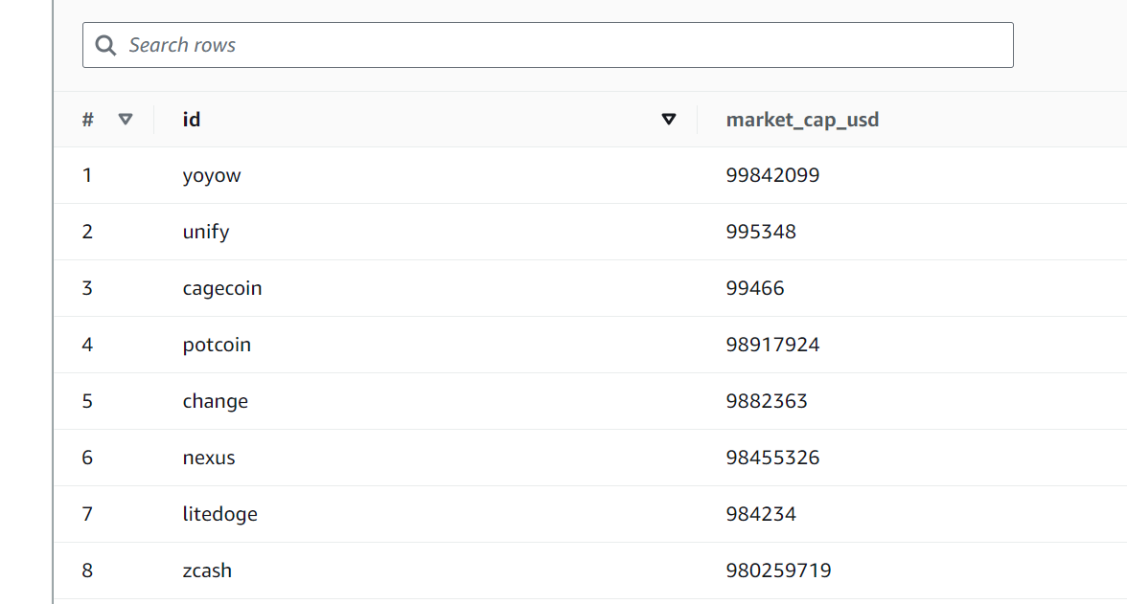

Cryptocurrency with Highest Trading Volume

### SELECT * FROM cryptodb

### ORDER BY CAST("24h_volume_usd" AS DECIMAL(38, 2)) DESC

### LIMIT 10;

### 

### 

### 

1. Cryptocurrency with the Lowest Trading Volume

SELECT * FROM cryptodb

WHERE "24h_volume_usd" IS NOT NULL AND "24h_volume_usd" != 0.0

ORDER BY CAST("24h_volume_usd" AS DECIMAL(38, 2)) ASC

LIMIT 10;

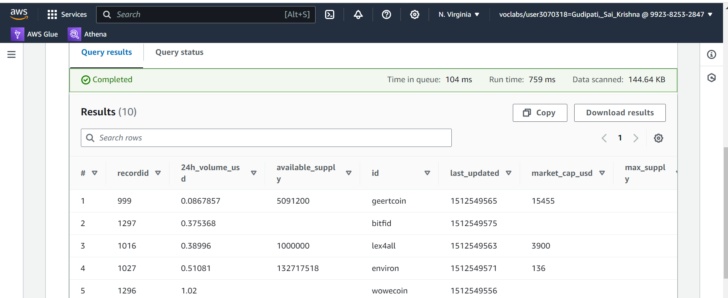

1. Cryptocurrency with the Largest Price Increase

SELECT symbol,

MAX(CAST(price_usd AS DECIMAL(38, 10))) AS max_price,

MIN(CAST(price_usd AS DECIMAL(38, 10))) AS min_price,

(((MAX(CAST(price_usd AS DECIMAL(38, 10))) - MIN(CAST(price_usd AS DECIMAL(38, 10)))) / MIN(CAST(price_usd AS DECIMAL(38, 10)))) * 100) AS percentage_increase

FROM cryptodb

GROUP BY symbol

ORDER BY percentage_increase DESC

LIMIT 10;

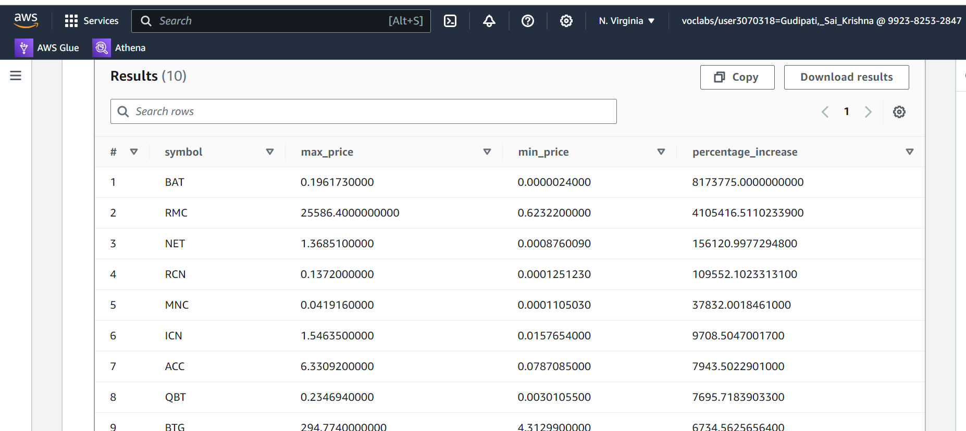

1. Cryptocurrency with the Largest Price Decrease

SELECT symbol,

MAX(CAST(price_usd AS DECIMAL(38, 10))) AS max_price,

MIN(CAST(price_usd AS DECIMAL(38, 10))) AS min_price,

(((MIN(CAST(price_usd AS DECIMAL(38, 10))) - MAX(CAST(price_usd AS DECIMAL(38, 10)))) / MAX(CAST(price_usd AS DECIMAL(38, 10)))) * 100) AS percentage_decrease

FROM cryptodb

GROUP BY symbol

ORDER BY percentage_decrease DESC

LIMIT 10;

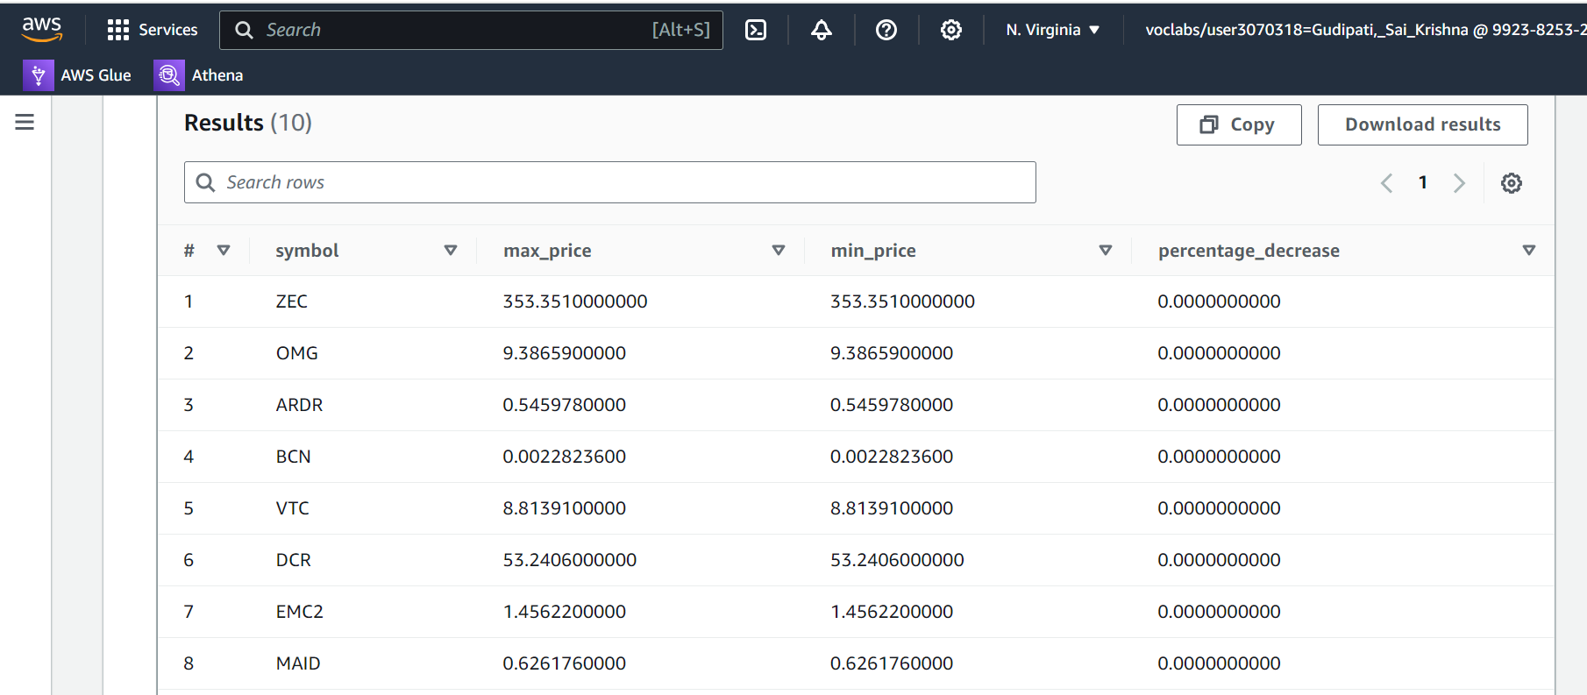

1. cryptocurrencies with the largest supply

SELECT id, max_supply

FROM cryptodb

WHERE available_supply IS NOT NULL AND available_supply != '' AND available_supply != '0'

ORDER BY CAST(available_supply AS DECIMAL(38, 0)) DESC

LIMIT 10;

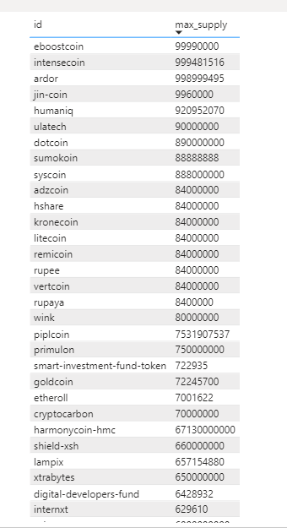

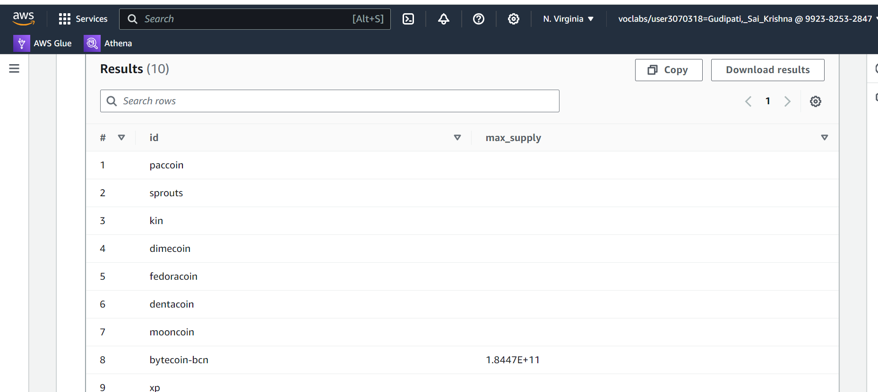

1. Cryptocurrency with the Smallest Circulating Supply

SELECT id, max_supply

FROM cryptodb

WHERE available_supply IS NOT NULL AND available_supply != '' AND available_supply != '0'

ORDER BY CAST(available_supply AS DECIMAL(38, 0)) ASC

LIMIT 10;

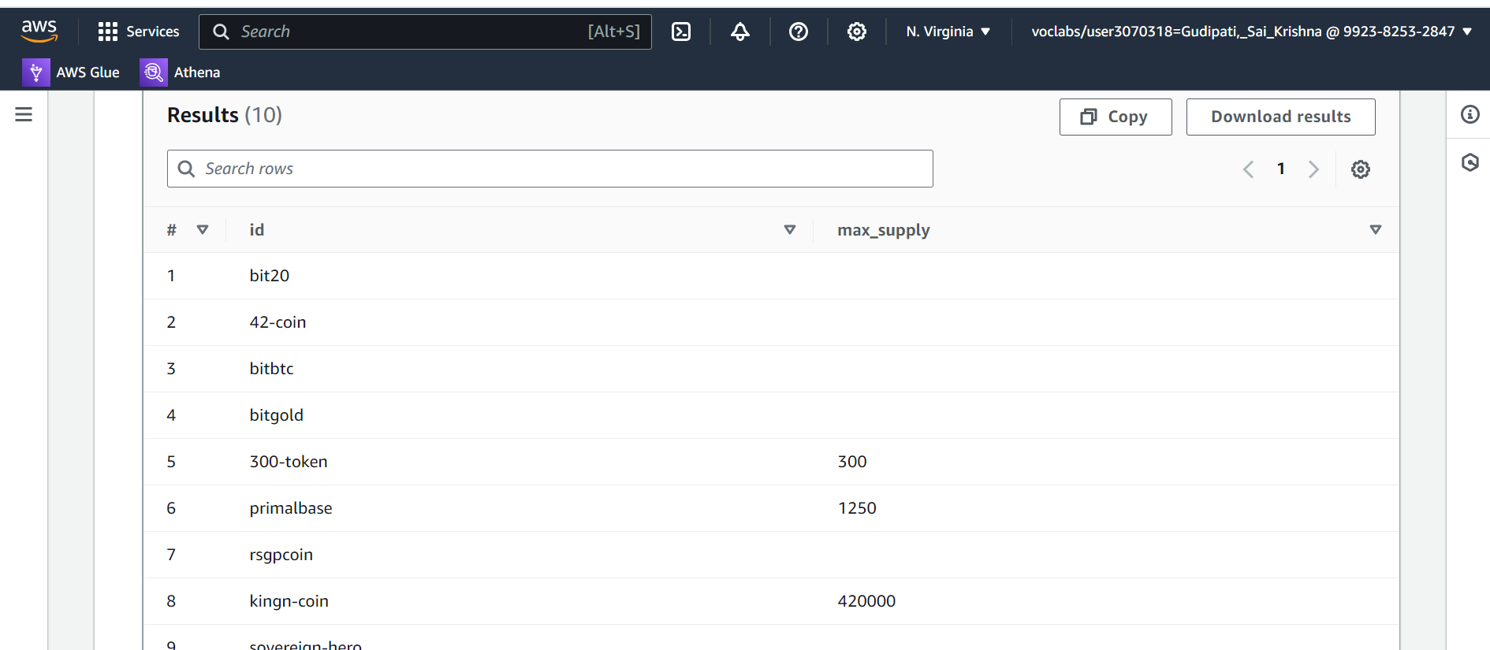

1. cryptocurrencies that have experienced the largest price increase over the given time period of seven days

SELECT symbol, percent_change_7d

FROM cryptodb

ORDER BY "percent_change_7d" DESC

LIMIT 10;

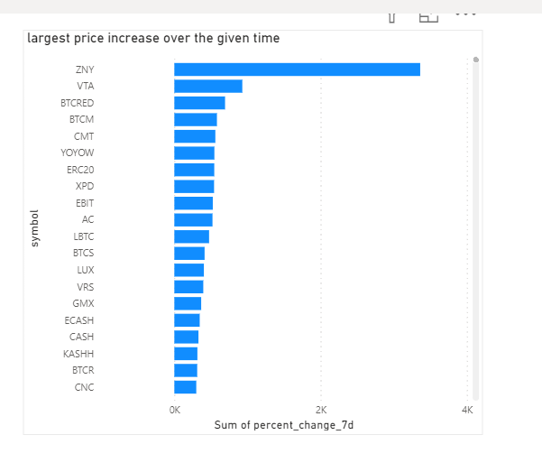

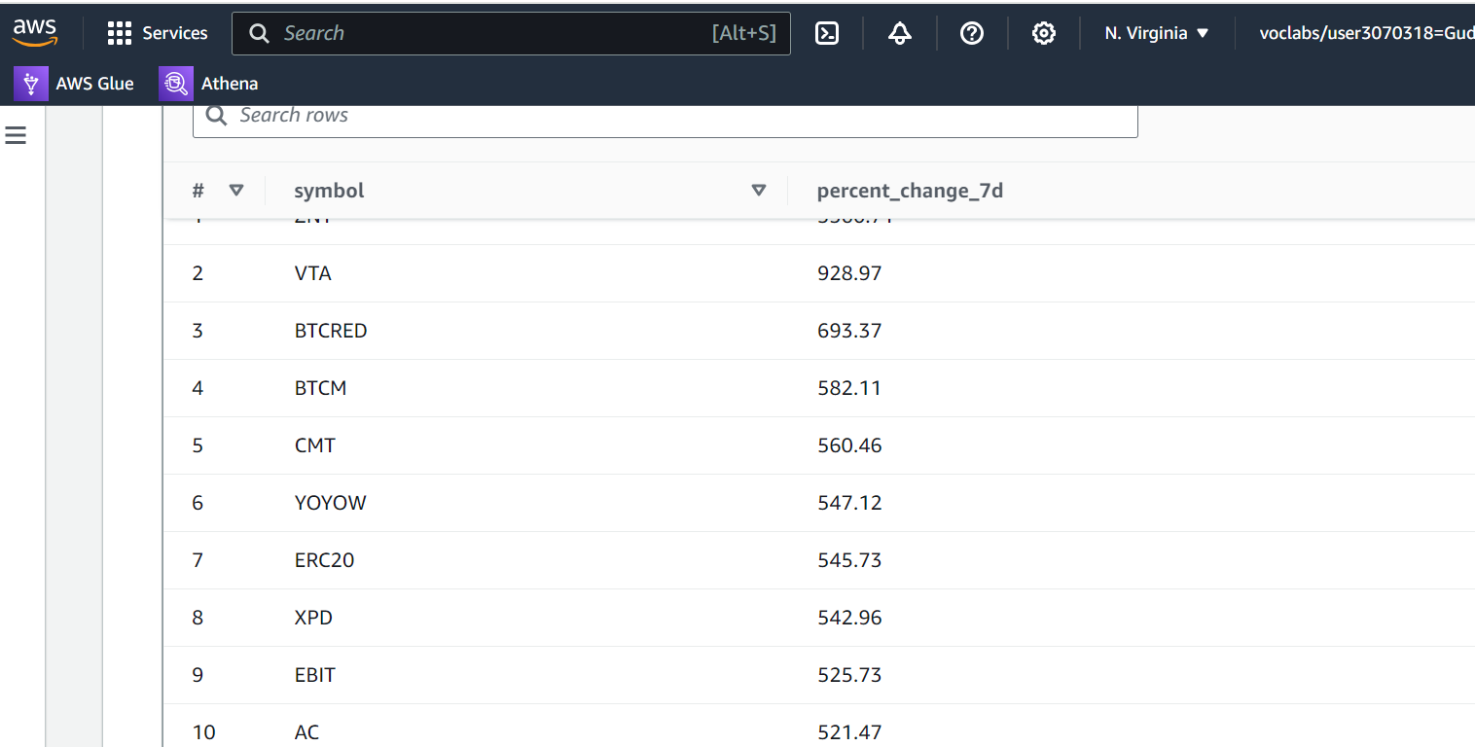

1. cryptocurrencies that have experienced the largest price decrease over the given time period.

SELECT symbol, percent_change_7d

FROM cryptodb

ORDER BY "percent_change_7d" ASC

LIMIT 10;

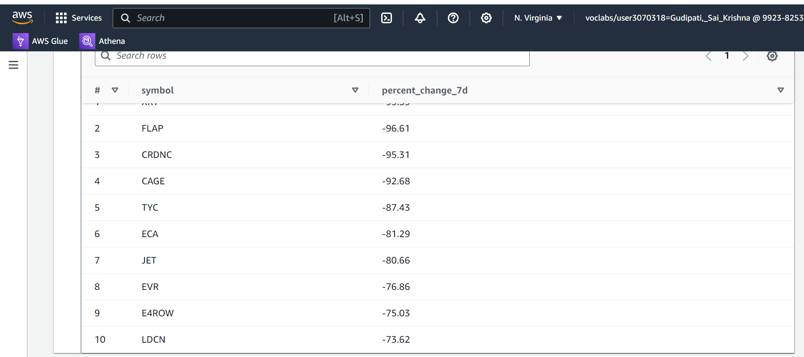

1. **Cryptocurrency Ranking Analysis:**

SELECT symbol, rank

FROM cryptodb

ORDER BY rank;

